

אוניברסיטת בן-גוריון בנגב

Ben-Gurion University of the Negev

הפקולטה למדעי ההנדסה

המחלקה להנדסת חשמל ומחשבים

Faculty of Engineering Science

Dept. of Electrical and Computer Engineering

פרויקט הנדסי שנה ד'

Fourth Year Engineering Project

Preliminary report

[Brain tumor segmentation using deep learning](http://projects.ee.bgu.ac.il/zf/public/projects/projinfo/id/s-2018-104)

סגמנטציה של גידולים מוחיים באמצעות למידה עמוקה

|  |  |  |
| --- | --- | --- |
| מספר הפרויקט: | p-2018-049 | Project number: |

|  |  |  |
| --- | --- | --- |
| סטודנטים  (שם ו ת.ז.): | Roy Hirsch 305052920  302724893 Ori Chayoot | Students  (name & ID): |

|  |  |  |
| --- | --- | --- |
| מנחים: | Dr. Tammy Riklin Raviv | Supervisors: |

|  |  |  |
| --- | --- | --- |
| תאריך הגשה: | 2017 | Submission date: |

Table of Contents:

1. Abstract in Hebrew: 9

2. Abstract: 10

3. Research goals: 11

4. Research Proposal: 13

5. Literature review: 14

5.1. Brain tumor 14

5.2. NN architectures 14

5.3. Segmentation methods 15

5.3.1. Traditional segmentation methods 15

5.3.2. Deep learning segmentation methods 16

6. Planning proposal: 19

6.1.Suggested method: 19

6.2.Prior assumption: 21

6.3.Optional difficulties: 21

6.4.Final testing proposal: 22

7. Working method: 23

7.1.Working methodology: 23

7.2.Schedule: 23

7.4. Budget estimation 24

7.4.1. Salaries and human resources: 24

7.4.2. Equipment and parts: 24

8. References: 26

1. Abstract in Hebrew:

סגמנטציה של גידולים מוחיים באמצעות למידה עמוקה

שמות הסטודנטים: אורי חיות, רועי הירש.

[*roymhirsch@gmail.com*](mailto:roymhirsch@gmail.com)

מנחה: ד״ר תמי ריקלין-רביב

גידול מוחי הוא מצב בו מתרחש גידול לא מפוקח ולא נורמלי של תאים הנמצאים במוח. הגידול המוחי הנפוץ ביותר בקרב מבוגרים הינו "גליומה" ומקורו בתאים הגליאלים, תאים אשר מספקים תמיכה והגנה לעצבי המוח, משמידים פתוגנים ומסירים תאים מתים [2][1]. הגידול מורכב מארבע חלקים עיקריים: האזור הפעיל (enhancing), האזור הנקרוטי (necrotic), ליבת הגידול ואזור בצקתי [4] [3].

במהלך האבחון והטיפול בהתקדמות המחלה נעשה שימוש בסריקות MRI אשר מספקות הדמיה תלת ממדית של המוח ושל הגידול. לרוב ניתוח ההדמיות נעשה על ידי רופאים, ידנית ובאופן איכותי בלבד כאשר ניתוח התמונה עלול להיות שונה בין רופא אחד לאחר. החלפת הניתוח הידני בניתוח אוטומטי טומנת בחובה פוטנציאל לשיפור האבחון והטיפול בחולה תוך ניצול זמן הרופא באופן מיטבי [4]. בנוסף, צורת הגידול על שלל מרכיביו אינה בעלת מאפיינים ברורים ולכן לשימוש באלגוריתם יתרונות נוספים.

בפרויקט זה נפתח אלגוריתם אופטימלי אשר ימומש בעזרת רשת נוירונים אשר יבצע סגמנטציה לרכיבי גידול ה"גליומה" מתוך הדמיות MRI . רשת נוירונים הינה מערכת לומדת המורכבת ממספר שכבות. המידע הנכנס לרשת מעובד בכל שכבה בהתאם לפרמטרים המוגדרים בה. הרשת מאומנת בצורה איטרטיבית על ידי הזנת דוגמאות אימון וביצוע תהליך אופטימיזציה לפרמטרים של כל שכבה ושכבה. לאחר אימון מוצלח הרשת צפויה לבצע סגמנטציה מדויקת על דוגמות חדשות. במהלך הפרויקט נבחן ארכיטקטורות מתקדמות לביצוע סגמנטציה ונממש פתרון אופטימלי וכולל לבעיה המוצגת.

מילות מפתח: גליומה, למידה עמוקה , למידת מכונה, גידול מוחי , רשתות נוירונים, סגמנטציה, רשתות קונבולוציה, MRI .

1. Abstract:

[Brain tumor segmentation using deep learning](http://projects.ee.bgu.ac.il/zf/public/projects/projinfo/id/s-2018-104)

Students names: Ori Chayoot, Roy Hirsch.

[*roymhirsch@gmail.com*](mailto:roymhirsch@gmail.com)

Advisor: Dr. Riklin Raviv Tammy.

Brain tumor is a state in which cells form in an abnormal way and without supervision. The most common brain tumor type among adults called Glioma and it is originated from the Glial cells, these cells provide protection and stability to the brains neurons and destroys pathogens [1][2]. Spatially the Glia tumor can be divided to four regions: tumor core, enhancing tumor, necrotic tumor and the edema [4].

In order to evaluate the disease’s progression and give suitable treatment a 3D MRI scan is used. In current clinical routine, the resulting images are evaluated based on qualitative criteria only, preformed manually and the analysis often differs between doctors [3]. Replacing the current procedure with an automated analysis has great potential for improving the patient’s treatment and will allow to utilize the physicians time better [4]. Additionally, duo to the verity of tumor structures an automated algorithm may bring more accurate results.

In this project we will develop an optimal algorithm using neural networks for segmenting Glioma tumors from MR images. Neural network is a learning system which consists of varied number of layers, each layer transforms the data with respect to the layer’s parameters. The network adjusts the parameters of every layer in an iterative optimization process. At the end of the learning process the network should be able to classify unseen data with high accuracy. During the project we will examine state-of-the art neural networks architectures for segmentation and will present an optimal solution to the presented problem.

Key Words: Glioma, deep learning, machine learning, brain tumor, neural networks, segmentation, convolutional networks, MRI.

1. Research goals:

Our project main goal is to develop state-of-the-art algorithm for semantic segmentation (per pixel) of tumor components in multimodal brain MR images automatically and reliably.

This goal can be divided to several objectives:

1. Deep research of traditional segmentation methods and segmentation using neural networks.
2. Implement a traditional segmentation algorithm for experiencing and exploring the dataset [5].
3. Research and study of state-of-the-art neural networks architectures and in particular convolutional neural networks.
4. Implementation and optimization of segmentation neural network for the segmentation. The networked will be trained and optimized to the MR images dataset.
5. Research Proposal:

Our product will be an algorithm implemented in Python which will be able to process and segment brain multimodal MR images with high accuracy. The algorithm will be trained on BRATS image dataset, the Multimodal Brain Tumor Image Segmentation Benchmark. (http://www.braintumorsegmentation.org). The algorithm will be tested evaluated on an unseen test data. The output of the algorithm is a segmentation map of the input image (with the ability to label four different tissue areas).

Our algorithm will consist the following components:

* Preprocessing of the input data for a homogenous dataset, for example: intensity correction and images registration.
* Features extraction, for example: voxel-wise features, textural and spatial features and intensity distribution using deep learning algorithm and architecture such as convolutional networks.
* Classification stage which segment each voxel’s class based on the scores that each class achieved. [6][7]

Block diagram:

**Loss function (Train)**

(Softmax, Hinge etc.)

**Preprocessing**

(Registration, intensity correction, etc.)

**Features extraction**

(Convolution layers, dropout layers etc.)

**Classification (Test)**

1. Literature review:
   1. Brain tumor

On type of cells that can be found in the brain are the Neuroglial cells, also referred to as glial cells or simply glia and are quite different from the brains nerve cells. Glia are more numerous than neurons in the brain, outnumbering them by a ratio of perhaps 3 to 1[_1_] Gliomas are brain tumors in adults, presumably originating from glial cells and infiltrating the surrounding tissues. Gliomas are divided into Low Grade Gliomas (LGG) and High Grade Gliomas (HGG), which are the more aggressive form of the disease [_2_]. The glioma is spatially consists of 4 parts: The non-enhancing solid core, the enhancing tumor, necrotic core and the edema [_3_].

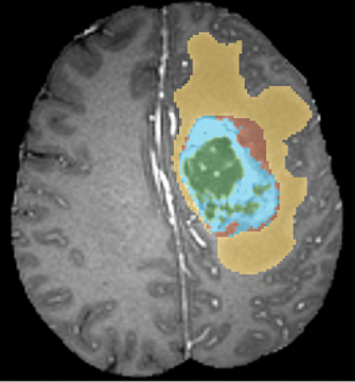

***Fig.[1]: Glioma sub-regions:***

*Yellow: the edema.*

*Red: The non-enhancing solid core.*

*Blue: the enhancing tumor.*

*Green: the necrotic core.*

* 1. NN architectures

A neural network is a parallel distributed information processing structure consisting of processing elements interconnected together with unidirectional signal channel called connections. Each processing element has a single output connection which branches into as many collateral connections as desired. The processing element can be of any mathematical type desired [4]. In order to train a net to predict an output there are two methods, supervised and unsupervised learning. For the supervised learning the net will receive both an input training data and ground truth labels while in unsupervised learning the NN will receive the training data without ground truth labels. The learning process consists of 2 parts. The first part is forward pass in which data is fed into the net and flows through its layers and a cost function will calculate the accuracy of the output computed. The second part is back propagation in which methods such as gradient decent will be used in order to minimize the cost function by changing parameters of the different layers. Since NN usually use large amount of parameters in order to fit the training data, common effect is that the net fits the training data but doesn’t fit the unseen test data. This phenomenon called overfitting and there are various ways to overcome it such as adding regularization factor to the cost function or use dropout in the NN layers [_5_]. The large amount of parameters is also a computational difficulty while training the net. In order to reduce the number of parameters an architecture of Convolutional layers is proposed (CNN). In this type of architecture, the input of each layer uses shared weights (kernel) in order to preform leaner computations. These computations are usually followed by non-leaner activation functions which creates features maps and some layers will also include subsampling (or pooling) layers [_6_].

* 1. Segmentation methods

Most of the current brain segmentation algorithms can be divided into two groups:

Generative models – uses prior knowledge about different tissue types of the brain (like spatial or appearance knowledge). Models from this family will may use brain atlas and will compare the input data to a known and expected tissue example to track changes.

Discriminative models – learn directly from labeled training data and its characteristics. Models from this family require amount of training data and uses classification methods to learn boundaries between the classes. There are also newer methods that offers fusions of the two algorithms families.

We will focus on discriminative methods (which may also contain generative models). We can classify discriminative methods to traditional methods and deep learning methods.

* + 1. Traditional segmentation methods

Traditional segmentation methods implement in a similar pipeline: pre-processing, features extraction, classification and post-processing. Pre-processing step may involve noise removal, skull-stripping and intensity and bias correction. Feature extraction is done using image processing techniques and statistical calculations. Traditional classifiers that shows great results are random forest (RF).

Random forest:

A supervised learning method which consist from two stages, training and testing [9]. As a first step, feature vector is being extracted for every training example. A decision tree is a basic unit of random forest. During training of decision tree, each tree node learns to classify the input data by specific feature. The training data is divided in every node and is based on the features of the data. The result is a structure which contains many nodes and divides the data to classes based on features. At testing, new test data is being pushed to the tree root until it reaches a leaf. A leaf node represents the tree classification. Random forest is a large collection of de-correlated decision trees. Each tree in being built based on a subset of training examples from the dataset [10]. While testing, each tree will predict a classification for the test data and most probable class will be noted as the forest prediction. This classification method proved to be very efficient in classification and segmentation missions. Some modification and improvements of the basic method described above were used on BARTS dataset over the years [4].

* + 1. Deep learning segmentation methods

Recent performances of deep learning methods, specifically Convolutional Neural Networks (CNNs) in object recognition and image segmentation increased their popularity among researches. In contrast to tradition methods, in CNN the features are learnt automatically and directly from the training data. In our days, the state-of-the-art segmentation results are obtained using CNN and therefore we will focus on this technic’s architectures:

SegNet –encoder/decoder

CNNallow us to create deep architecture with relatively small amount of parameters. CNN have proven good candidates for tasks of object detection where the number of classes to label the pictures was usually smaller than the amount of pixels in an image – therefore the output of the net was smaller than the input. Due to this, one could build an architecture where each layer is smaller than its previous. In semantic segmentation this is not the case, the output of the layer needs to be equal to the input size. In order to answer this need on one hand and on the other hand creating large receptive field on deep layers, SegNet propose an encoder decoder architecture:

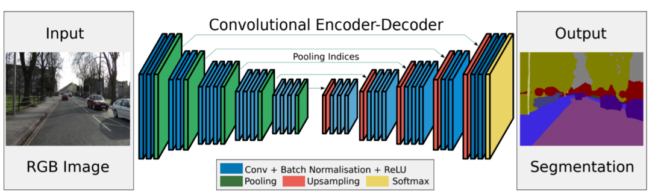

*Fig [2]. Encoder-Decoder architecture.*

As shown in fig [2] the encoder is consists of feature maps followed by ReLU and a pooling layer ( this way the last map has relatively large receptive field). After pooling, the net remembers what was the spatial location from which it pooled the value. Later each layer of the encoder uses the spatial location in order to create it’s the up sampling layer. After locating the values to their original location, each of the features maps are created using different kernels. At the end of the net Softmax layer is used as cost function [_7_].

3D CNN / DeepMedic with residual connections

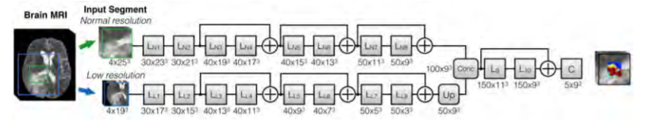In order to utilize the spatial connection between voxels the use of 3D kernels is proposed. One of the state of the art architectures that demonstrate use of these kernels is Deep medic with residual connections. The architecture consists of 2 paths: The first use high resolution patches ($4X{25}^{3})$ and the second is low resolution patch ($4X{19}^{3})$. The use of low resolution allows to create a net that use spatial connections between voxels that are far away without the need to create deep architecture. Furthermore this architecture uses residual connection which have shown small but consist improvement from DeepMedic without residual connections [_8_][_9_].

*Fig [3]. DeepMedic arthitecture.*

RNN

Recurrent neural networks (RNNs) initially designed for sequence processing, they achieve great results for speech recognition and machine translation [11]. RNN basic architecture contains a hidden layer state which contains the last step of the net, during computation of the *i’s* state we will use the hidden state of the (*i-1*) state (as can be seen in Fig.[4]). This network architecture contains a “memory” of the last stage and is able to achieve more accurate results based on sequential data.

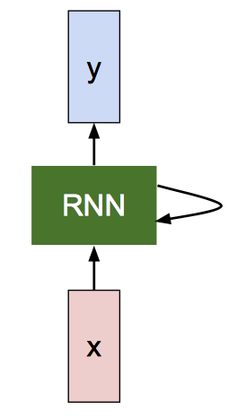

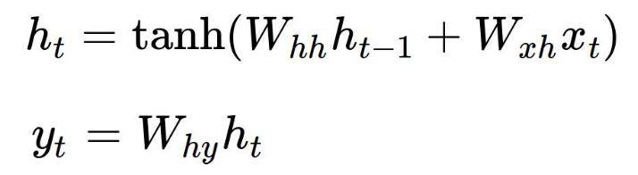

*Fig. [4]. A schematic structure of RNN network. Yt is the output of the RNN layer, ht­ is the hidden layer (function of the previous layer, the current state and a tanges function).*

A common example of this model is long short-term memory (LSTM). An LSTM block contains a memory vector which “remembers” values from the previous steps. An LSTM block is composed of four components [12]:

Input gate – input vector to the LSTM cell.

Output gate – control which values to reveal from the cell.

Cell gate – defines which values will be written to the cell (marked as ‘g’).

Forget gate – controls which values will remains in memory. Each of the gates has its own parameters (weights and biases). Example to an LSTM cell:

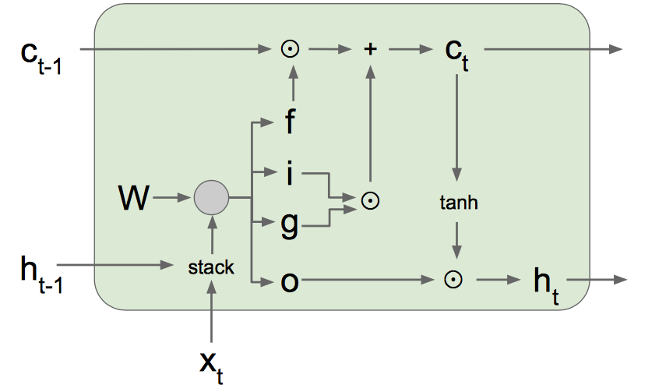

(b)

(a)

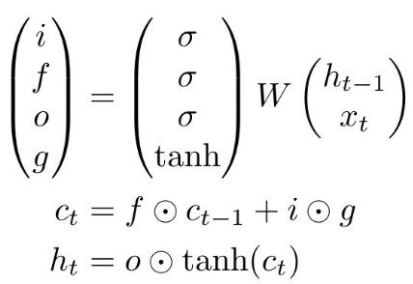

*Fig. [5]. (a) Basic LSTM cell equations where $σ$ is the sigmoid function and*[*hyperbolic tangent*](https://en.wikipedia.org/wiki/Hyperbolic_tangent)*function. (b) LSTM basic cell flow chart.*

The LSTM architecture handles with a common problem of RNN network – exploding/vanishing gradient. An LSTM network may contain several blocks of LSTM with connection of dropout/fully connected layers. Recent works explored the use of LSTM and RNN networks for image segmentation. In this use case the spatial domain replaces the time domain in the model, image patched are fed to the network in a sequence and the segmentation method takes advantage of the internal memory of the network [13].

1. Planning proposal:
   1. Suggested method:

Our research will start by implementing a traditional image segmentation algorithm. We chose to implement Random Forest (RF) segmentation method, as was described in the previous section. Implementing this segmentation algorithm will also us to get familiar with the BARTS dataset and how to perform basic image processing manipulations on it. After implementing the traditional segmentation method and evaluating our success will conduct a deep learning segmentation method.

We would implement a deep learning solution based on recurrent neural neatwork (RNN) architecture. A 3D biomedical image is often represented as a sequence of 2D slices (a z-stack). Recurrent neural networks, especially LSTM, are an effective model to process sequential data. Inspired by these facts, we propose to use the sequential memory of the LSTM network in order to gain relevant spatial information. The use of LSTM on 3D image patches/2D slices in multiple directions may achieve promising results.

There are few issues to the known neural networks 3D segmentation methods. First, simply linking 2D segmentations into 3D cannot leverage the spatial correlation along the z-direction. We basically loss relevant information with the decision to test every slice separately. Second, incorporating 3D convolutions may incur extremely high computation costs (high memory consumption and long training time). There are methods for spatial feature extraction, but we believe they are still losing important spatial contact.

Recently, a new model named “Reseg” was introduced for semantic segmentation of 2D images using recurrent neural networks [13]. In this architecture a convolutional neuron network extracts features from the image. Patches from the output image are fed into 2-dimentional RNN network. At the end of the RNN two features map are composed – vertically (O↕) and horizontally (O↔). The vertical feature map (O↕) elements (o↕i,j) can be seen as the activation of a feature detector at the location (i, j) with respect to all the patches in the j-th column of the input. Respectively we can describe the horizontal features map. Then up-sampling layers using transposed convolution are applied to extend the output image dimensions. The network was trained and optimized based on this architecture and showed great results.

Another work showed great progress by implementing a framework based on fully convolutional network and recurrent neural network on 3D image segmentation tasks [14]. In the model the data was fed to a bi-directional convolutional LSTM (BDC-LSTM) to capture the contextual information from the Z- and the Z+ planes. More advanced model named Deep BDC-LSTM was introduced, applying directional LSTM layers in six directions for 3D spatial context (X-/+, Y-/+, Z-/+). The two models were tested on ISBI neuron dataset and Neuron in-house 3D fungus datasets and showed great results.

Inspired by those works, we would like to implement a network architecture that will use the advantages of RNN in order to enhance the segmentation accuracy of the network. As first step, the network may contain pre-processing stage for preparation of the data. Secondly, a convolutional neural network will extract features from the data. Then a RNN block will add the spatial context to the model. A schematic figure of the network can be shown on Fig.[]

**Convolutional neural network**

**3D RNN model**

**Pre-processing**

*Fig. [6]. Suggested neural network architecture.*

* 1. Prior assumption:

Several prior assumptions guided us through the planning process, and will guide use through the execution of the project.

* BRATS dataset – we will train and test our data on the BRATS dataset. The dataset contains number of dozens of images that have been pre-processed before. A strong assumption is that this amount of data is sufficient for a good optimization of our network (usually lots of data is required for training). Moreover, the processed data should be homogenous, if we would need to re-process the data once more for our use we need to take this into consideration.
* Neural networks are a relevant tool for this segmentation task – a relevant question to ask is “does neural networks may obtain better results for this segmentation task?”. We confronted this question at the beginning of our research and we state that the use of NN for brain tumor segmentation tasks shows significant results and it is the state-of-the-art solution for this problem nowadays [8]. To support this claim we can show that neural networks have showed Dice score of 87%, 88% and even 91% for the whole tumor segmentation.
  1. Optional difficulties:
* Time limitation and estimation – our research and implementation time may take more then we initially expected. Our project proposal includes deep research and then implementation with a new technology, those processes may take time. Moreover, segmentation of brain tumor region in MR images in known to be a complex and challenging mission. In order to achieve our goal for optimal algorithm for this problem in the time frame we have we will follow a well-planned schedule (see section 7, working method). In addition, we have declared a sequence of milestones along the project schedule to make sure we are within the time frame.
* Technical implementation difficulties - we will implement our network using Python packages and modules we are currently unfamiliar with. We may have technical difficulties while trying to implement and examine our algorithm. In order to reduce our technical difficulties, we will start building the neural network code framework in the early stage of the project (see section 7). In order to deal better with technical difficulties we will learn from the basic relevant Python packages and their use (like TenzorFlow), and will build smaller educational projects first. We will also consult external experts and other students in the image processing lab at BGU if needed.
* Implementing inefficient neural network – it will be unfortunate if our final model will gain insufficient accuracy on the training data. In order to avoid this situation and to choose the right algorithm for implementation and testing we will follow those steps:

Basing our model on previous models or articles that proven to get good results. Trying (as we can) to implement the model on a batch of the data to get an intuition for its behavior. To consult experts and students with prior knowledge about our model.

* Insufficient budget – on the next section be will declare on a budget estimation for our project. In order to make sure our budget estimation is realistic we will consult our project advisor and experts with prior knowledge. Moreover, we will add a section of “unexpected expenses” to our budget estimation.
  1. Final testing proposal:

We will follow the evolution metrics as described by the BARTS challenge, in order to test our performance accurately in compare the state-of-the-art algorithms.

Three tumor regions segmentation will be evaluated: the whole tumor, the tumor core and the active tumor (the enhancing core). We will follow those evaluation metrics:

Dice – For each of the three tumor regions we obtained a binary map with algorithmic predictions P∈{0,1} and the experts' consensus truth T∈{0,1}. The Dice measure is calculated following this equation:

$$Dice= \frac{2\left|T_{1}∩P_{1}\right|}{\left|P_{1}\right|+\left|T_{1}\right|}$$

Hausdorff distance – a method for calculating distance between segmentation boundaries.

$$Hausdorff = max⁡\{\sup_{p∈∂P_{1}}{(\inf_{t∈T_{1}}{d(p,t)}),\sup_{t∈∂T_{1}}{(\inf_{p∈P_{1}}{d(t,p})) }}\}$$

A realistic success rate for our algorithm will be:

|  |  |  |  |
| --- | --- | --- | --- |
|  | Whole tumor | Tumor’s core | Active tumor |
| Dice score | 0.8 $±$ 0.1 | 0.7 $±$ 0.1 | 0.6 $±$ 0.1 |

1. Working method:
   1. Working methodology:

We developed a unique working methodology that will help us stand in our schedule:

* Weekly meeting synchronization meeting of the project members.
* Two predefined working days per week, those days will be dedicated to the project missions.
* Bi-weekly meeting with the project advisor.
* All project’s code and documents will be saved in a shared Git account.
* Missions and unsolved issues will be documented also in the Git project board and will be reviewed at least once a week in the synchronization meeting.
  1. Schedule:

In order to achieve our goals, we will follow the following working methodology:

1. Information gathering stage:
   1. Extensive research of relevant segmentation algorithms from BRATS challenge and other publications.
   2. Learning classic image processing and MR imaging.
   3. Experiencing with implementation of neural networks.
2. Evaluation and Implementation stage:
   1. Design and Implementation of state of the art algorithm.
   2. Evaluating and comparing the different algorithms.
   3. Changing and optimizing the algorithm.

|  |  |  |
| --- | --- | --- |
| End date | Start date | Task |
| 17/11/17 | 22/10/17 | Literature review, general segmentation methods. |
| 02/11/17 | 18/11/17 | Learning Tensorflow and implementing basic NN |
| 02/11/17 | 18/11/17 | Literature review – focus on traditional segmentation. |
| 16/12/17 | 02/12/17 | Building framework for NN |
| 13/01/18 | 02/11/17 | Execute MR image segmentation project using classic algorithms. |
| 30/12/17 | 16/12/17 | Literature review – focus on Neural networks, different architectures compare. |
| 17/02/18 | 10/02/18 | Evaluation of the classic MR algorithm and design state of the art deep learning algorithm |
| 17/03/18 | 10/02/18 | Implementation of the deep learning algorithm. |
| 24/03/18 | 17/03/18 | Evaluation of the algorithm on the test data. |
| 24/03/18 | 17/03/18 | Comparison traditional segmentation algorithm and to the deep learning algorithm. |
| 14/04/18 | 24/03/18 | Further modifications for optimizing the leading algorithm. Re-evaluation of the modified algorithm. |
| 05/05/18 | 14/04/18 | Summery and reports |

* 1. Milestones:

|  |  |
| --- | --- |
| Task | Dou date |
| Finish traditional segmentation project | 13/01/18 |
| Deciding on a leading deep learning algorithm | 01/02/17 |
| Finish initial implementation of the suggested deep learning method | 17/03/18 |

* 1. Budget estimation
     1. Salaries and human resources:

|  |  |  |  |
| --- | --- | --- | --- |
| Part | Amount | Cost (per unit) | Total |
| Students | 700*2 | 80 NIS* | 120,000 NIS |
| External advisors | 50 | 400 NIS* | 20,000 NIS |

* + 1. Equipment and parts:

|  |  |  |  |
| --- | --- | --- | --- |
| Part | Amount | Cost/unit | Total |
| Matlab license | 2 | 800 NIS | 1800 NIS |
| External GPU | 2 | 1700 USD | 12,000 NIS |
| Server time | 200 | 10 NIS | 2,000 NIS |

Overall budget estimation: 155,800 NIS

Final budget estimation (15% of unexpected expenses): 180,000 NIS

1. References:
2. E. C. Holland, "Progenitor cells and glioma formation", *Curr. Opin. Neurol.*, vol. 14
3. D. Purves et al, “Neuroscience 3rd ," ed., Sinauer Associates, 2004
4. Friebolin, H., "Basic One- and Two- Dimensional NMR Spectroscopy, 4th ed.," VCH: Weinheim, 2008.
5. B. H. Menze, A. Jakab״, The Multimodal Brain Tumor Image Segmentation Benchmark (BRATS)״, Med. Im. vol:34 issue: 10.
6. P. Y. Wen, "Updated response assessment criteria for high-grade gliomas: Response assessment in neuro-oncology working group", J. Clin. Oncol., vol. 28, pp. 1963-1972, 2010.
7. C. Cortes, V. Vapnik, "Support-vector networks", Mach. Learn., vol. 20, no. 3, pp. 273-297, 1995.
8. Criminisi, J. Shotton, Decision Forests for Computer Vision and Medical Image Analysis, Germany, Heidelberg:Springer, 2013.
9. A. Isin, “Review of MRI-based Brain Tumor Image Segmentation Using Deep Learning Methods”, “Procedia Computer Science”, vol. 102, pages: 317-324.
10. Zikic D, et al. Decision forests for tissue-specific segmentation of high-grade gliomas in multi-channel MR. Med Image Comput Comput ,,Assist Interv 2012;15(3):369–76.
11. L. Breiman. Random forests. Machine Learning, 45(1):5–32, 2001.
12. M. F. Stollenga, W. Byeon, M. Liwicki, and J. Schmidhu-  ber. Parallel multi-dimensional lstm, with application to fast biomedical volumetric image segmentation. In *Advances in Neural Information Processing Systems*, pages 2980–2988, 2015.
13. S Hochreiter ,Long short-term memory. Neural computation 9 (8), 1735-1780, 1997.
14. F. Visin, M. Ciccone, A. Romero, K. Kastner, K. Cho, Y. Bengio, M. Matteucci, A. Courville, "Reseg: A recurrent neural network-based model for semantic segmentation", *IEEE Conference on Computer Vision and Pattern Recognition (CVPR) workshop*, 2016.
15. Chen, J., Yang, L., Zhang, Y., Alber, M.S., Chen, D.Z.: Combining fully convolutional and recurrent neural networks for 3D biomedical image segmentation. CoRR abs/1609.01006 (2016)